**XAVIER UNIVERSITY – ATENEO DE CAGAYAN**

**COLLEGE OF COMPUTER STUDIES**

**DEPARTMENT OF INFORMATION SYSTEMS**

**TMWS WATER BILLING SYSTEM**

A Project Presented to the Faculty of the

Department of Information Systems

College of Computer Studies

In Partial Fulfillment of the Requirement for the Course

ISc 34

by:

Baclayo, Harry

Baconga, Justine

Casinillo, Adrian

Faciolan, Jeffrey

Fuentes, Roniel

Lamique, Christian

Gallardo, Gian

Nocete, Tristan

Olinan, Uenice

Pelayo, John

Prejan, Christian

Quidong, Paul

Santos, Maria

Sara, Maryl

Sherry, Ronald

October 20, 2017

**Problem Identification**

The Talakag Municipal Water System is the only water provider in the Municipality of Talakag, supplying over 1500 consumers. They are responsible in facilitating the transactions and records of every water concessionaire in the Municipality of Talakag. They provide and encode the water meter readings of their consumers and send billings and notices every month.

It has been a challenge for the Talakag Municipal Water System to monitor the records of their consumers without a proper profiling system. They simply encode the records and transactions of over 1500 consumers with the use of Microsoft Excel, which takes a lot of work and time to do. Also, they need to manually calculate every water meter reading, summing up previous water meter readings with the present readings. Without a proper profiling system, delays and discrepancies occur. They should be able to distribute billings every month, however it will somehow reach more than that to do so. All payments are being done in the Office of the Treasurer of Talakag, so when it comes to disconnection, they sometimes forget to disconnect an unpaid consumer, supposedly the disconnection should be in 2 months, but without realizing, it will reach up to 5 months or to a year at the most. Moreover, some paid consumers are mistakenly disconnected from their supply.

**Requirements Determination**

The system is exclusively made for the Talakag Municipal Water System’s use. It will contain consumer profiles, showing their basic information, filtered by residential or commercial consumers. It will include each consumer’s billing history; consumption (water meter readings), bill amount, status and date.

This system was proposed to have a fast and precise profiling and transaction recording system for the Talakag Municipal Water System. This will allow them to properly monitor each consumer’s transaction status, to provide billings on time and disconnections when necessary. The system can also provide information as a basis of development and innovation of their current water meter reading calculation and water supply.

The system will have the following functions:

* It will require a user to login first before the system can be used, a valid username and password will be required.
* It will display an overview of the number of consumers who have paid and not paid their bills and the total number of consumers.
* It will show consumers as residential or commercial consumers.
* It will allow the user to add, remove, update information in the consumer’s profile and billing history.
* It will calculate the water meter readings which are indicated in cubic meter and display the total amount to be paid.
* It will show the consumer’s basic information (name, address, contact number and meter number), billing history (water meter readings, bill amount, status and date).

**System Analysis**

The web application will contain the profile of the consumers, transaction history and water meter reading calculation breakdown. The consumers will be filtered to residential and commercial consumers, as to there is a different water meter reading for each. It will show the consumer’s (residential or commercial) basic information (name, address, contact number and meter number) and billing history (water meter readings, bill amount, status and date).

This system was proposed to have a fast and precise profiling and transaction recording system for the Talakag Municipal Water System. This will allow them to properly monitor each consumer’s transaction status, to provide billings on time and disconnections when necessary.

A replacement for the current method of listing their consumer's billing record monthly. We target the aspect which requires their effort of having to input datum and calculate the datum manually. The parts are the Consumer's Profile; having the basic details enlisted by the past bills, Current Amount; subtracting the past and present value, Current Consumption; translated by the previous reading labeled in Cubic Meter(m^) and Automated Bill Generator; Combining the Consumer Profile, Amount, Consumed, Talakag Header, Talakag Log

**System Design**

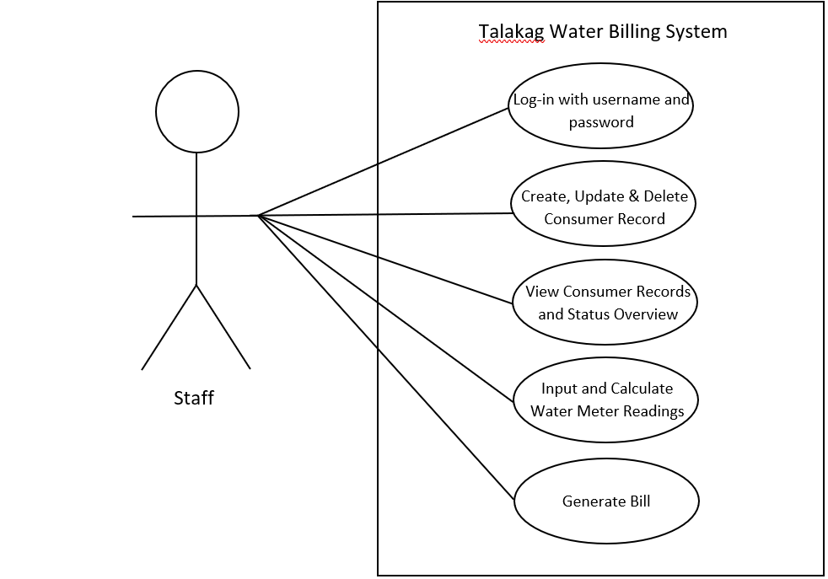Use Case Diagram

The system is operated by the appointed staff of the Talakag Municipal Water System. The staff then logs in into the system where he/she can create new accounts for consumers who haven’t had accounts in the database and update and delete the consumers’ records. By the time a consumer is on his/her date of billing, the staff would update the consumer’s records using the receipt from the treasurer then inputs the water meter reading and then prints out a bill for the consumer to have.

The TMWS (Talakag Municipal Water System) Water Billing System is a system where the staff of Talakag Municipal Water System would provide records, pending payments and current bills as well as updates to the consumers, who are registered in the database. In the system we made we created a use case diagram to show list of actions or event steps typically defining the interactions between a role of and a system to achieve a goal. The purpose of this case is to form a requirement model for Water Billing System for the Talakag Municipal Water System. The requirement model provides a referencing point for the development of a water billing system, and can be extended for use in development of other utility billing system in meeting the needs of system users and consumers.

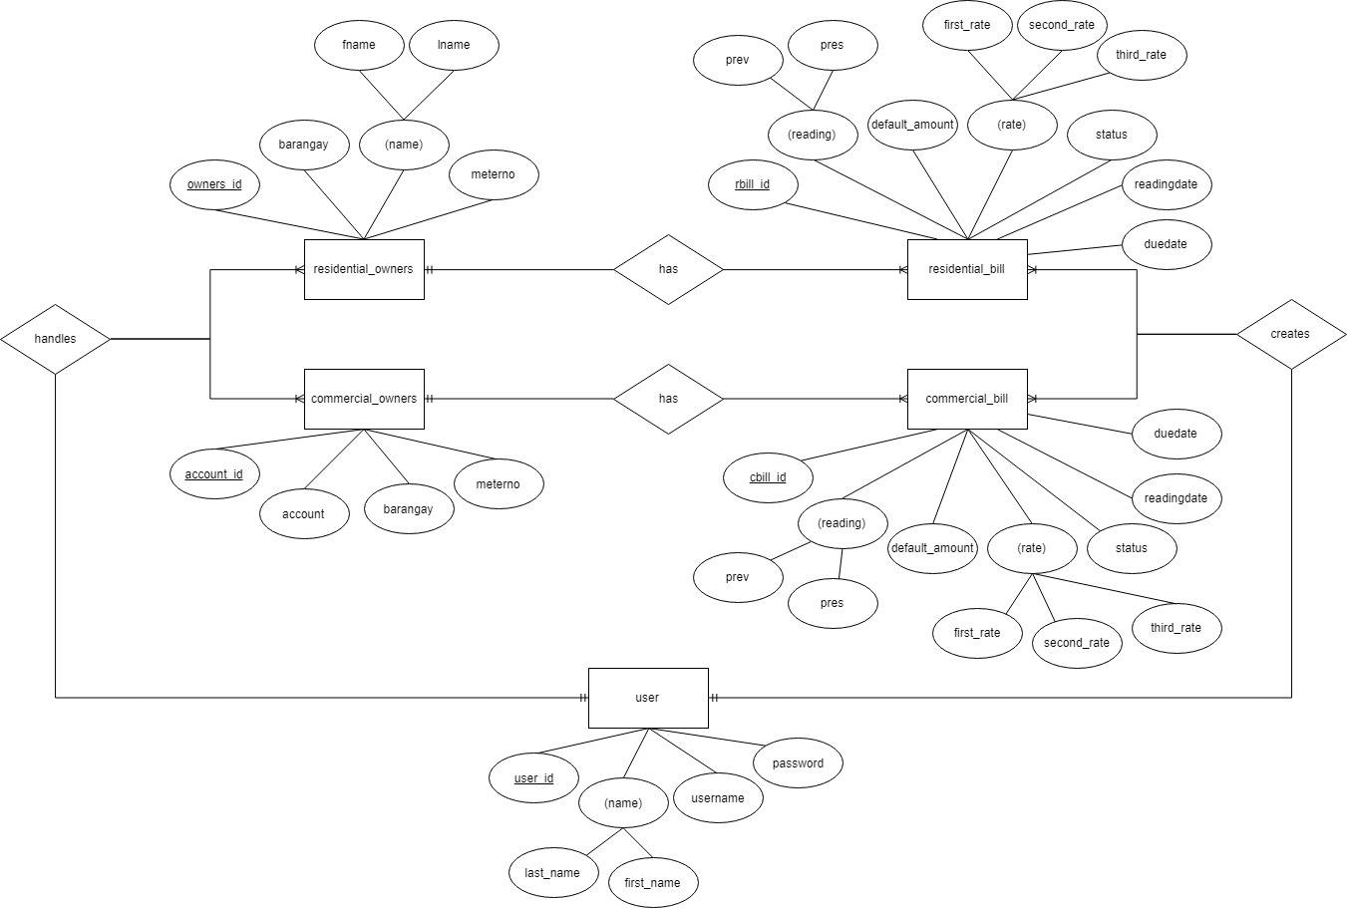Entity-Relationship Diagram

There are five entities in the TMWS (Talakag Municipal Water System) Water Billing System entity-relationship diagram. The first entity, residential_owners has four attributes: owners_ID, name which is further broken down as fname and lname, barangay and contact number. The residential_owners entity is connected to the the second entity, named residential_bill has seven attributes: rbill_id, reading which is further broken down as prev and pres, default_amount, rate which is further filed as first_rate, second_rate and third_rate, status, readingdate and duedate. The relationship of the two entities is that one residential_owners can have one or more residential_bill.

The third entity, named commercial_owners also has four attributes: account_id, account, barangay and meterno. It is connected to the fourth entity, commercial_bill which also has seven attributes: cbill_id, reading which is further broken down as prev and pres, default_amount, rate which is further filed as first_rate, second_rate and third_rate, status, readingdate and duedate. The relationship between the two entities is that one commercial_owners can have one or more commercial_bill.

The fifth and last entity, user has four attributes: user_id, name which is broken down into last_name and first_name, username and password. This entity is connected to all the other entities. One user handles one or more residential_owners and commercial_owners and one user creates one or more residential_bill and commercial_bill. This entity takes hold of all the other entities.

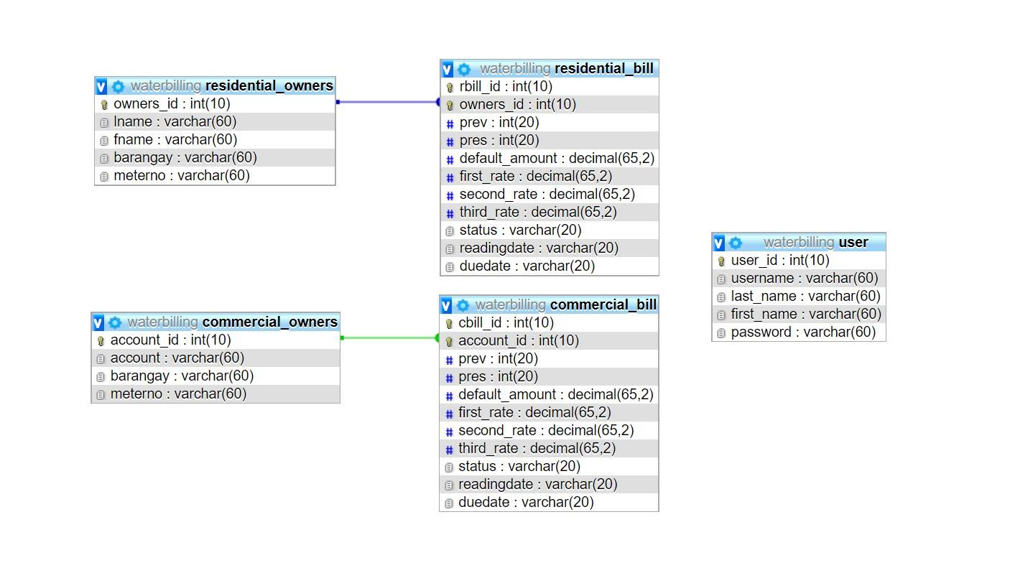Relational Model

The TMWS (Talakag Municipal Water System) Water Billing System’s relational schema comprises of five tables; Residential Owners, Residential Bill, Commercial Owners, Commercial Bill and User. This schema shows the structure of the database system. The Residential Owners table is connected to the Residential Bill table by the owners_id attribute, which is the primary key of the Residential Owners table and the foreign key of the Residential Bill table. Same goes with the Commercial Owners table, it is connected to the Commercial Bill table by the account_id attribute as primary key and foreign key of the two tables respectively. The User table stands alone with five attributes and is not connected to any of the other table because it serves as an external entity of the database system.

**System Development**

During the creation of the TMWS Water Billing System, particular tools were used in order to meet the desired outcome of the project scope. For the overall foundation of the system, we used XAMPP as a tool that offers a server locally and it has a built-in back end administration tool called phpMyAdmin for managing the database with MySQL. We then use PHP as our scripting language to store and retrieve the data from the database. For the front end of the system, we used HTML to prepare an overall layout. When it comes to the design and look of the system, we used some default Bootstrap CSS but altered some along the way to meet the desired look. JavaScript was also used to perform certain functionality to the system like sorting the table, prompting messages, modals, pagination and others.

Here are some screenshots of the look and functionality of the system:

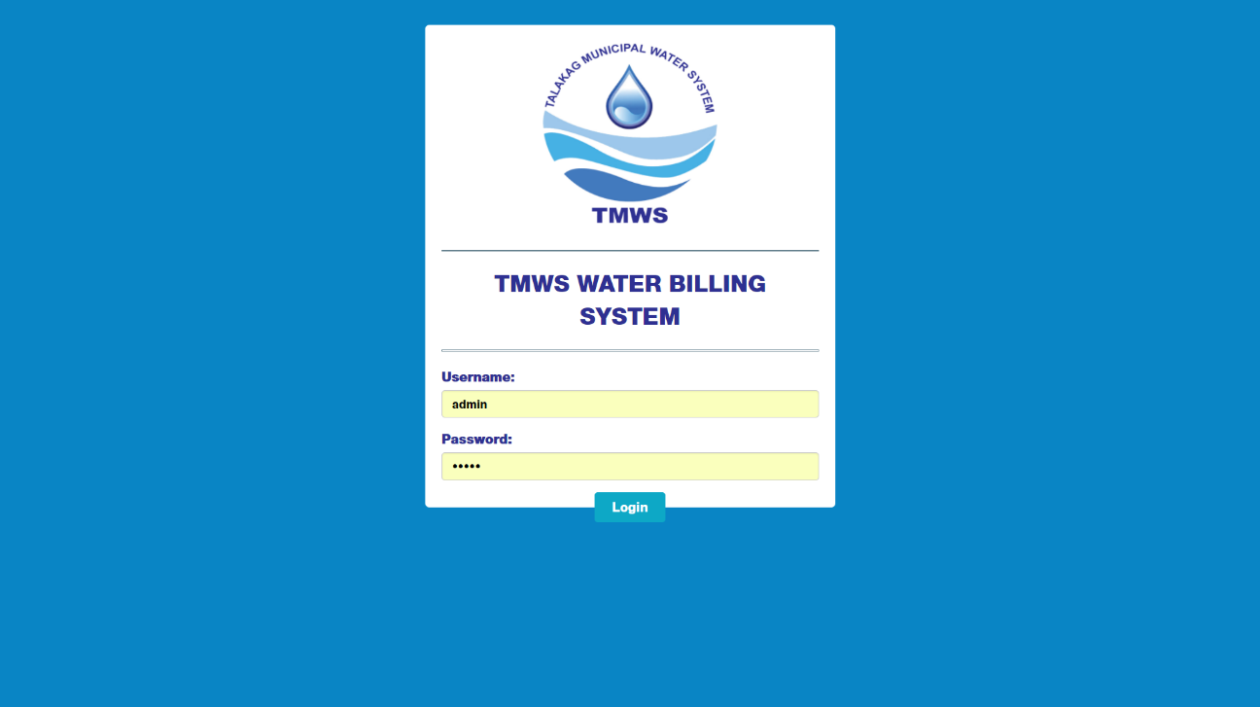Login Page

Homepage

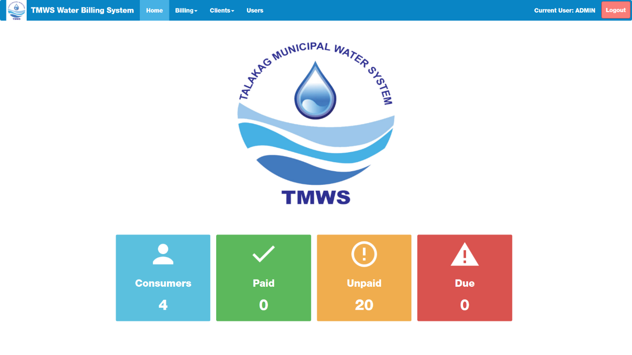

Residential Billing Page

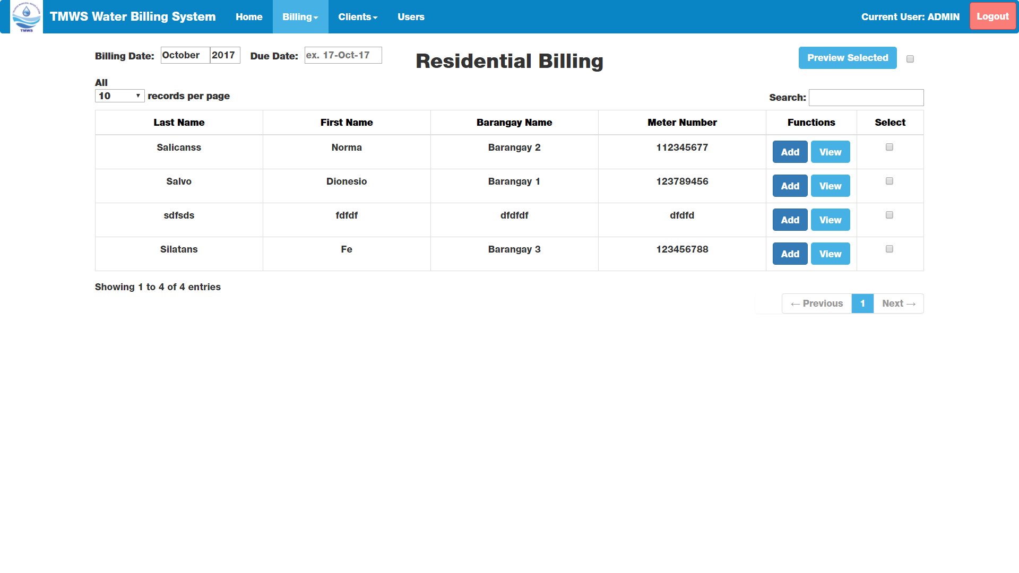

Commercial Billing Page

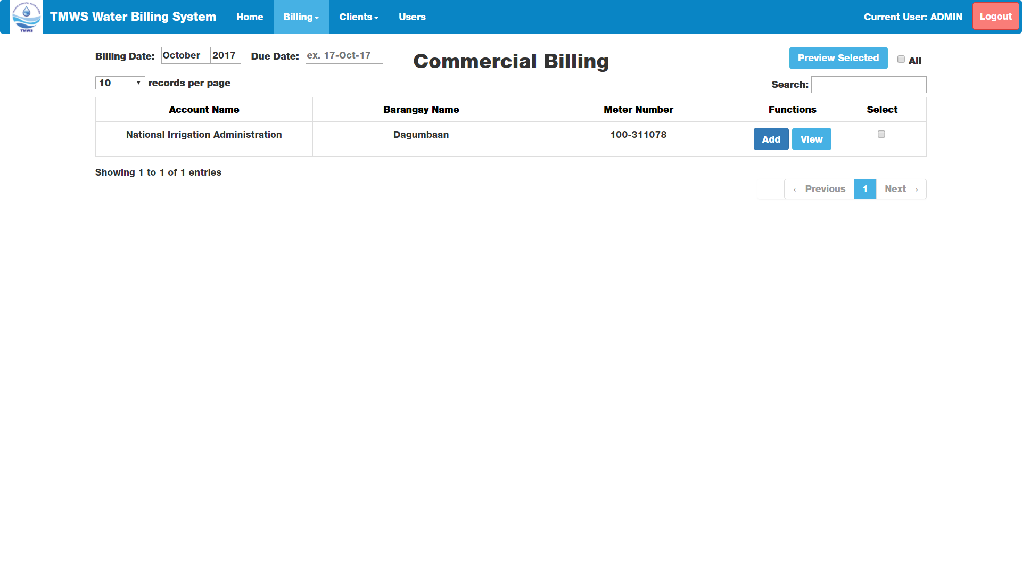

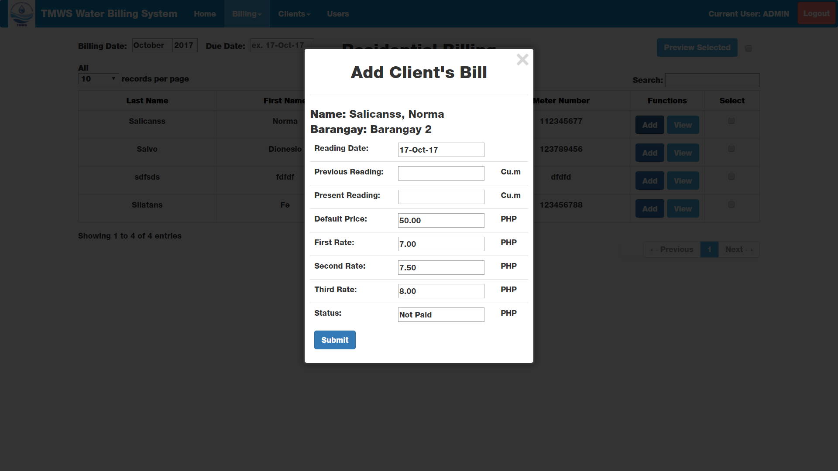Add Bill Window

View Bill Window

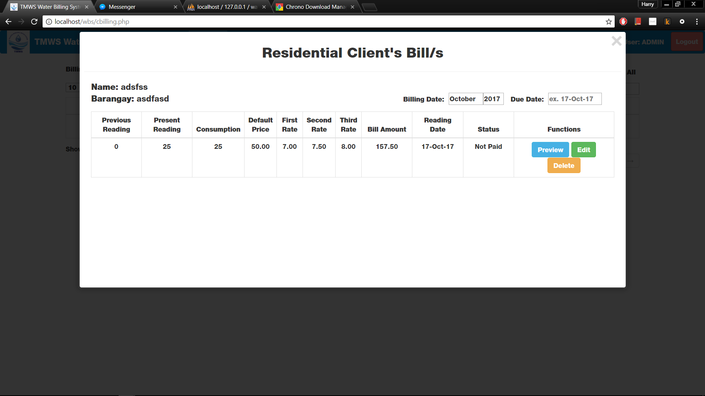

Client Profiles Page

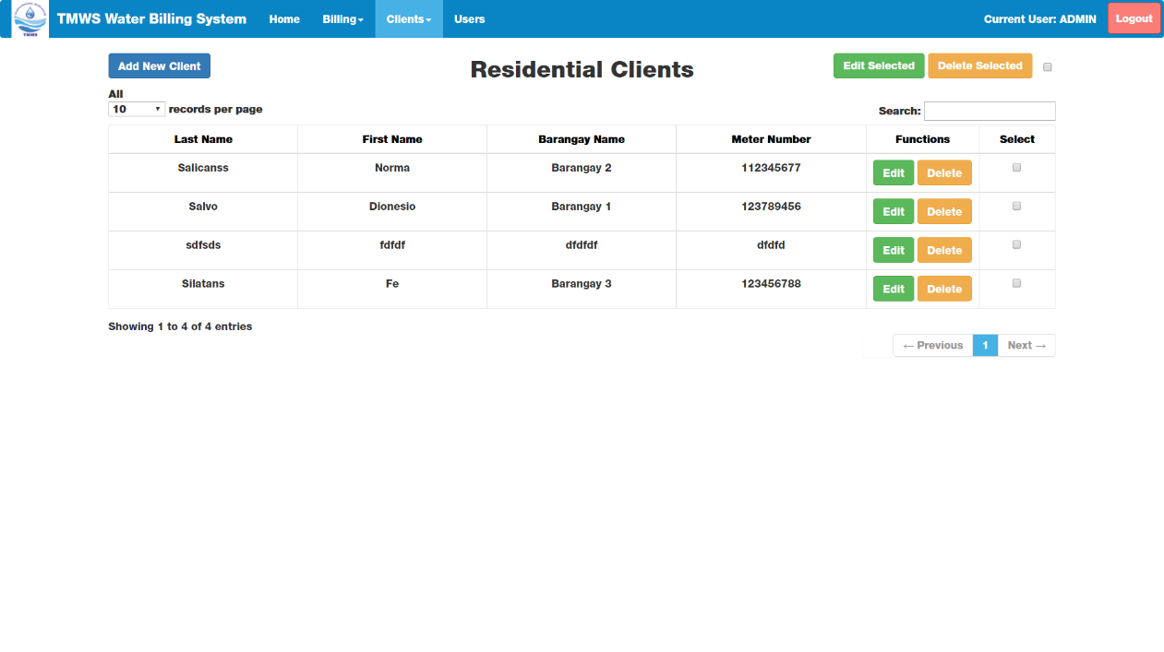

Editi Client Window

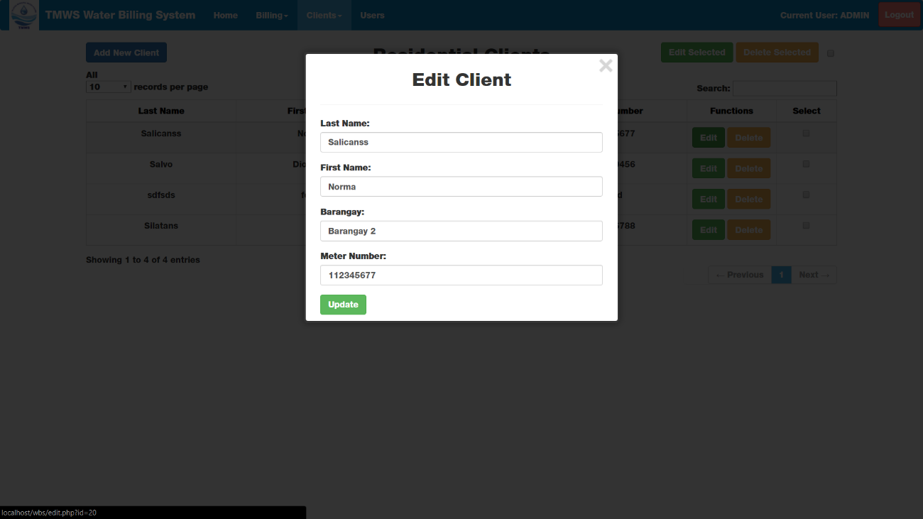

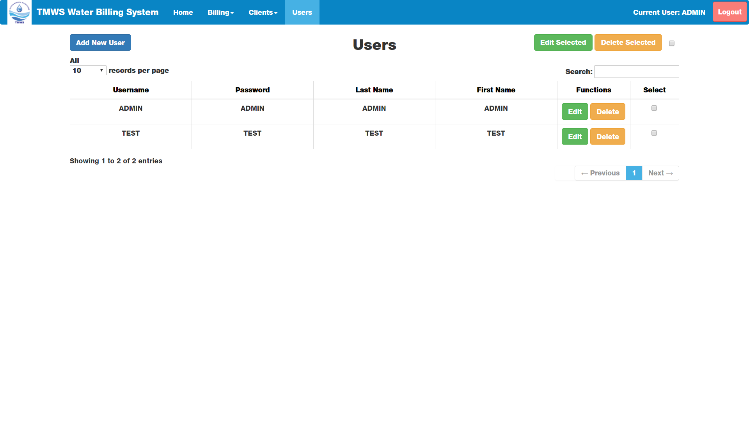Users Page

Add User Window

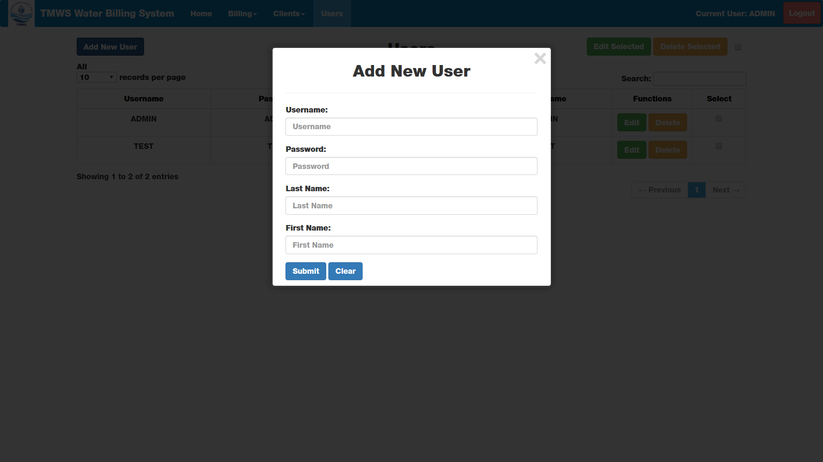

**Testing and Evaluation**

**TWMS Water Billing System Logo:** [HE-8 Aesthetic and Minimal Design]

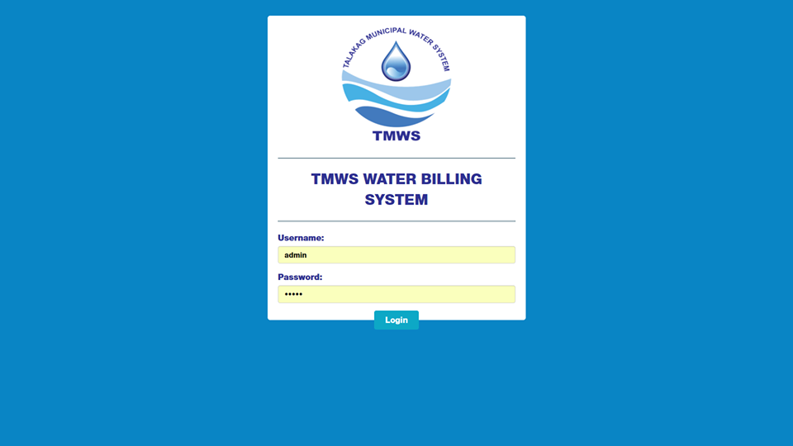**Login Page:** [HE-9 Help users recognize, diagnose, and recover from errors]

The logo was changed 3 times in its desired position.

When a user tried to log in, we found out that the system is case sensitive.

**TMWS Water Billing System Navigation Bar:** [HE-3 User and Control Freedom]

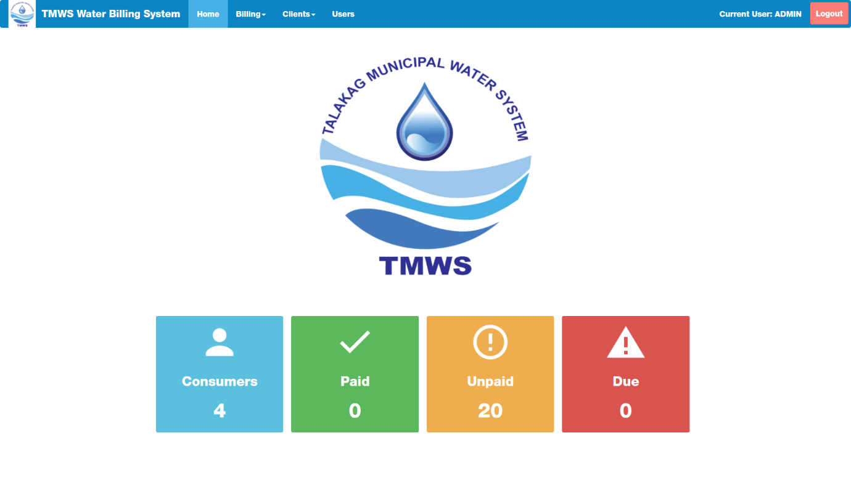

When you try to click the icons, it won’t display anything. You can just click it.

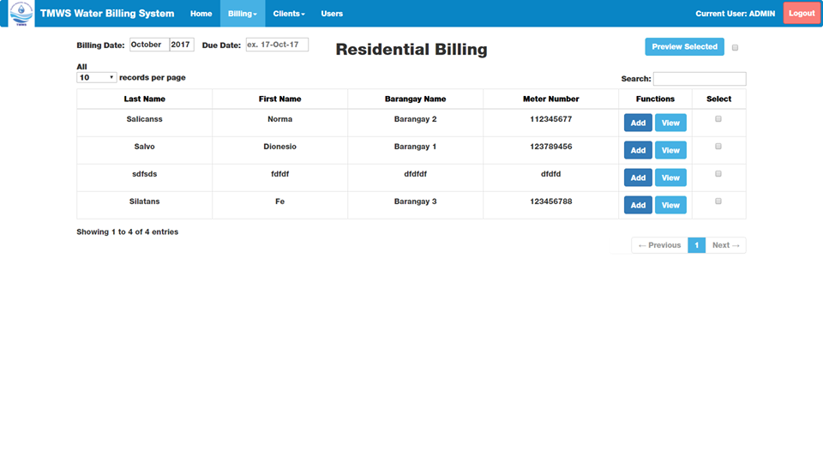**Residential Billing Page**: [HE-3 User control and Freedom]

When you try to input a due date, something will pop out “Please select a record”.

**Commercial Billing**: [HE-3 User control and Freedom]

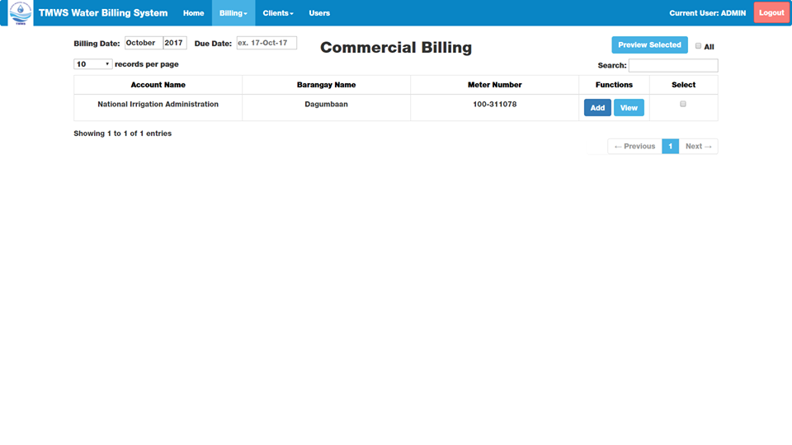

When you try to input a due date, something will pop out “Please select a record”.

**Commercial Clients:**

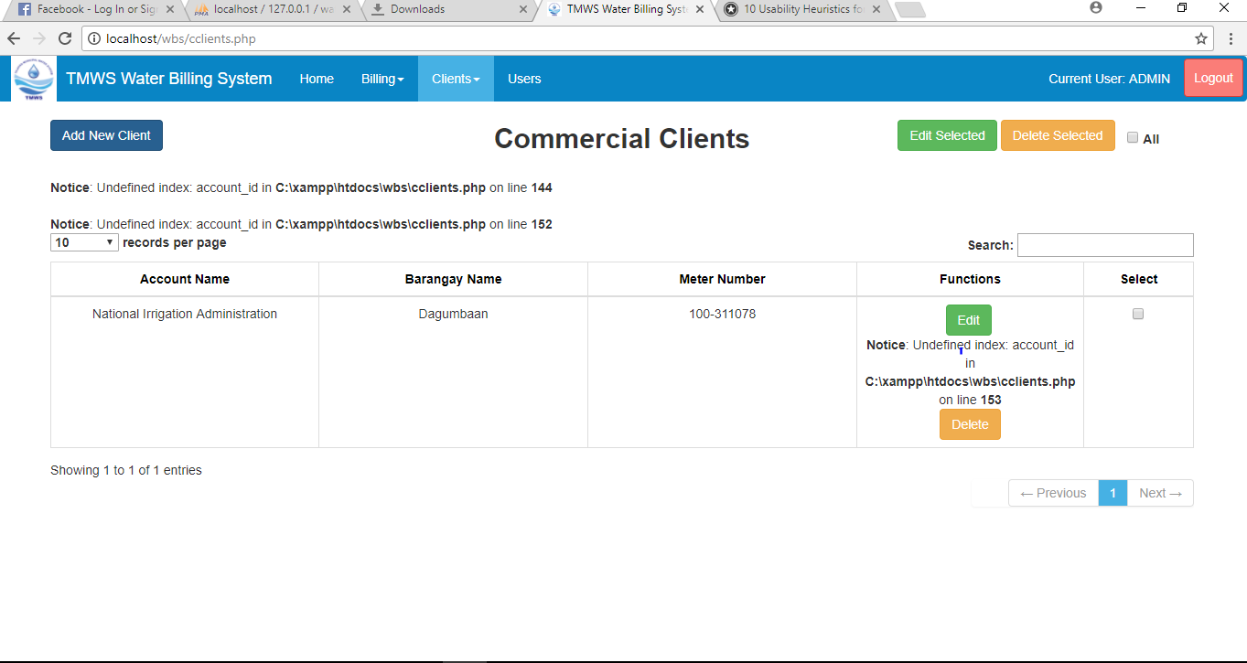**Edit & Delete buttons:** [HE-5 Error Prevention]

When you click the edit and delete button, something will pop out. It is an error, there will be a box and the only thing the user can do is to click the exit to go back to this page.

**Residential Client’s Bill/s:**

**Due Date:** [HE-4 Consistency and standards]

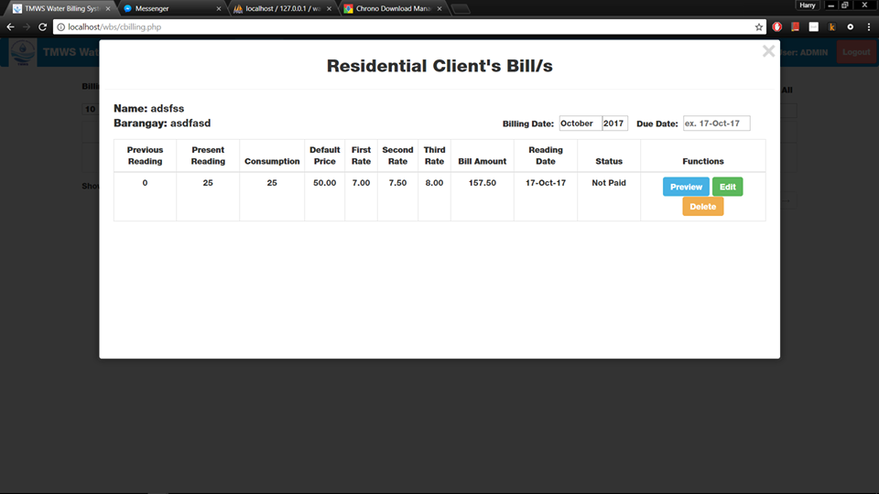**Functions**: [HE-5 Error Prevention] and [HE-8 Aesthetic and Minimal Design]

When you input a due date, there is nothing to show.

When you click preview, you can see the official receipt but there is an error on line 94.

The icons PREVIEW, EDIT AND DELETE are too big and they should be in one line to avoid unorganized table.

**Edit Client:** [HE-9 Help users recognize, diagnose and recover from errors]

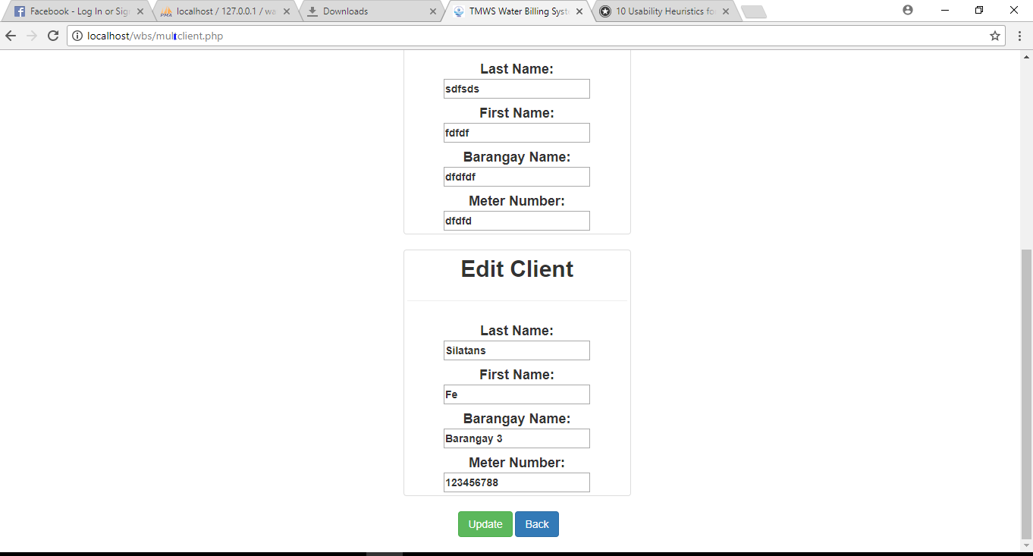

When you try to edit ALL, you will be directed to all users and you can edit everything but when you click BACK there will be an error 404.

**System Deployment**

The TMWS (Talakag Municipal Water System) Water Billing System will have two instances in deployment, one (1) If we, the development team will gather and travel to Talakag to supervise the installation of the system or Two (2) If the staff in charge will be assigned to install the system.

First Instance; Seven members of our team will travel from Cagayan De Oro to Talakag, Bukidnon and bring the required files for the installation: XAMPP Installer and TMWBS Files which includes the documentation. Three members of our team will transfer the files to the system host and follow the procedure to install accordingly accompanied by the remaining members to further explain for clarification.

Second Instance; A staff from Talakag Municipal will be shown a demonstration from the installation to interaction of the system and clarify specific areas that needed further explanation requested by the staff.